MULTIBRANCH PIPELINE

whenever we create a simple pipeline, we are able to work on the single branch that we specify in the pipeline but using multibranch we will work on multiple environments at a time

like test, development and production

suppose we have 3 branches in remote repository using multibranch we have the chance to work on those environments at a time. In single click it will create 3 jobs

but pipeline script is mandatory in those branches

step take one ec2 instance and install java, maven and Jenkins

start the Jenkins service

In Jenkins GUI

Create a job using multibranch pipeline

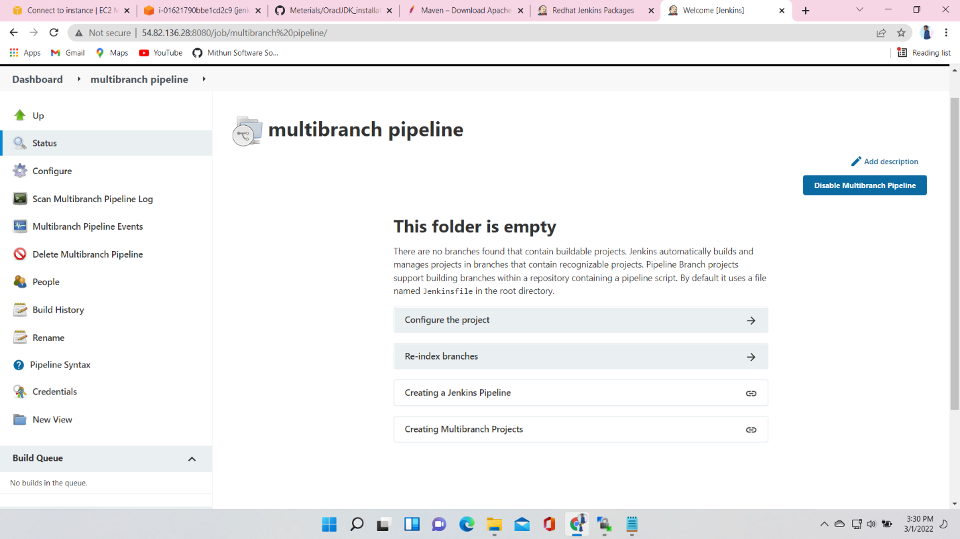

After creation of the job go to build and add source

Here I am adding my Github URL

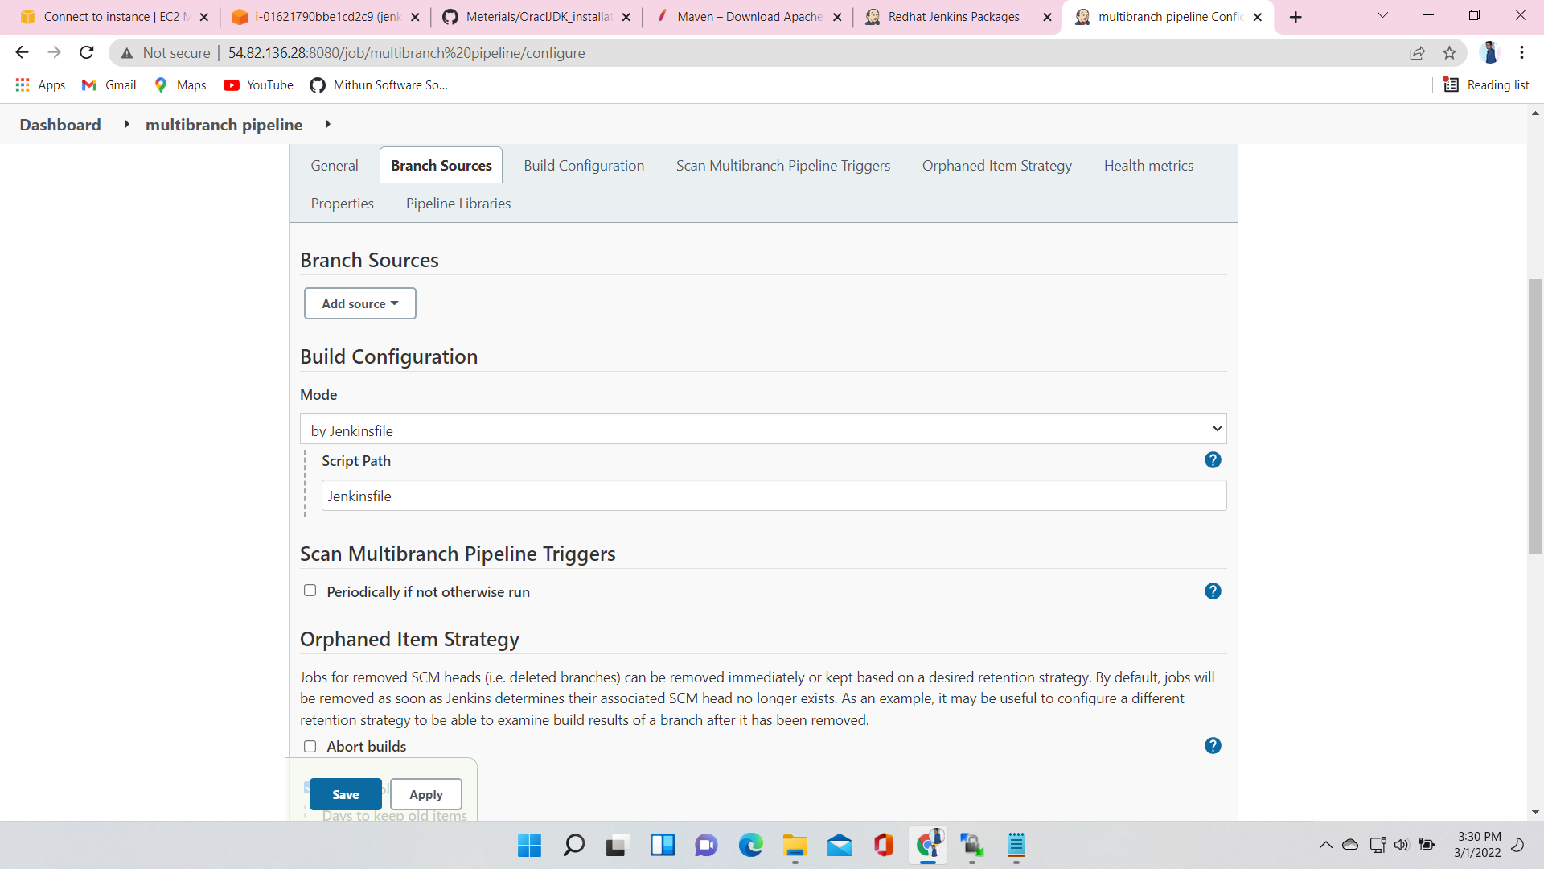

Here provide your github url

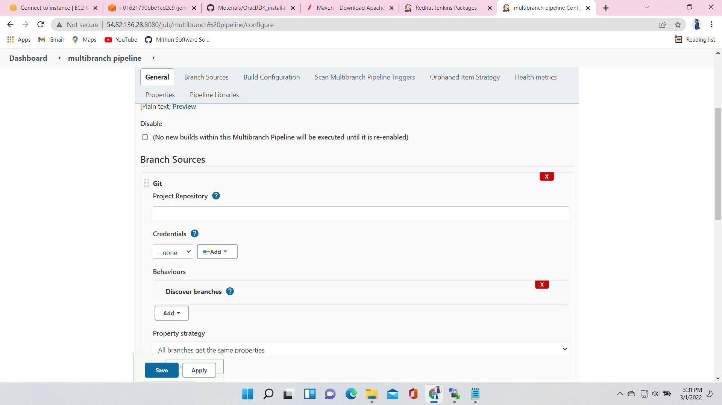

In Build Configuration give Script Path here I am given Jenkins

Here we have one build triggerer “Periodically if not otherwise run” here I am give 1 minute. in every minute it will check the script in github and if any changes will be there in it. It will start the build

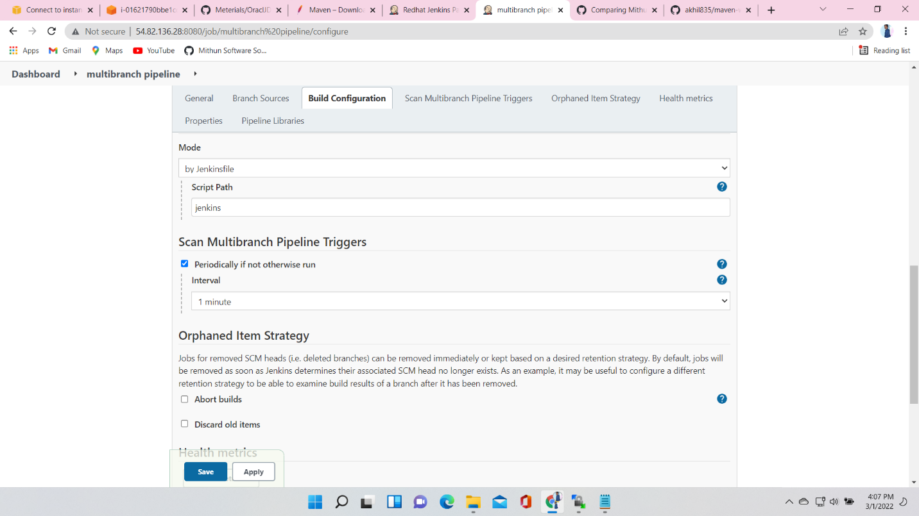

I have 4 branches in my remote Repository 5 of them 3 have pipeline script

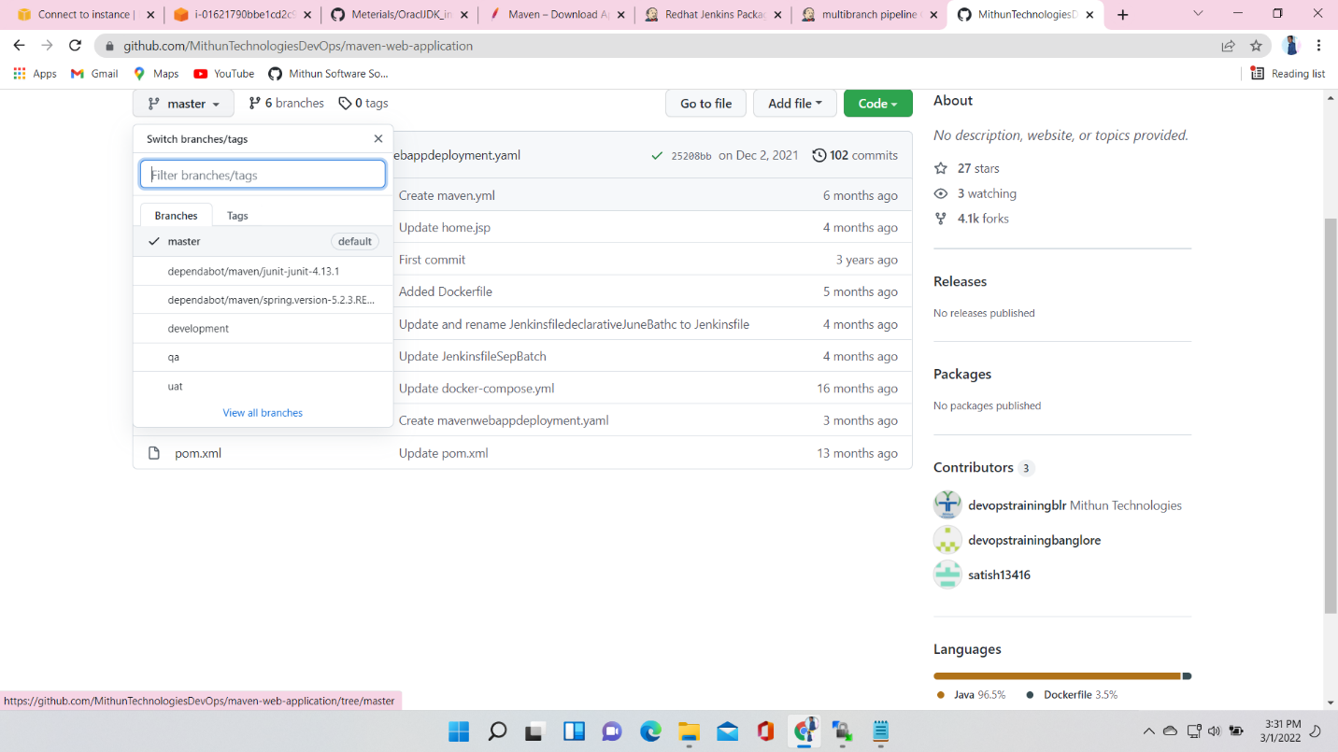

After completion of all those steps if we click apply it will starts build

It will check all the branches and start the build which branch have script path

